ToDo Management System
(Created By- Amrin Mulani)

Date-28 June 2019 mulani.amrin09@gmail.com

Details of Project-
Created By: | Amrin Mulani
Frontend Technologies: | HTML5, CSS3, JS, Bootstrap and Angular
Backend Technologies: | NodeJS, ExpressJS and Socket.IO
Tools: | Visual Studio Code,Mongo Compass,GitHub,AWS EC2,Route 53
Database: | MongoDB
Url: | http://todomanagement.tk
Api Doc Url: | http://api.todomanagement.tk/
GitHub Repository for Code: | Frontend- https://github.com/AmrinMulani/taskmanagement-frontend.git  Backend -https://github.com/AmrinMulani/taskmanagement-backend.git

User Management
SignUp -

User can signup in the application by providing the below details
- First Name
- Last Name
- Email address
- Password
- Country
- Mobile number
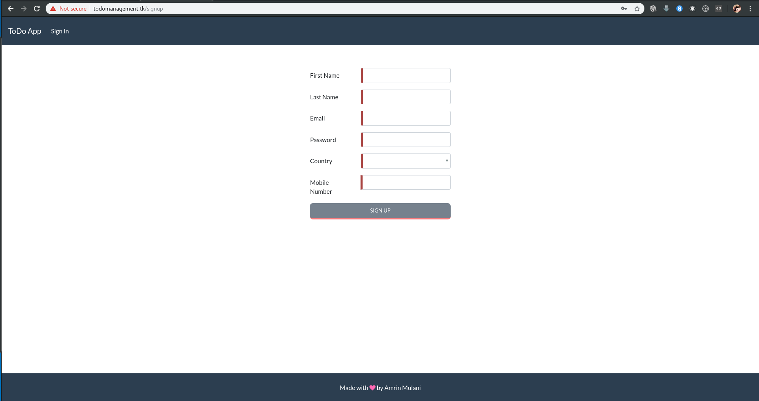

Login-
After succesfully signup user able to login by providing the email and password of user
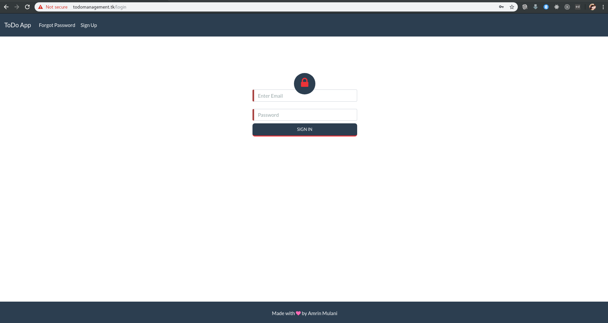

Forgot password-
If user forgot the password by click on forgot password user will receive email for reset the password
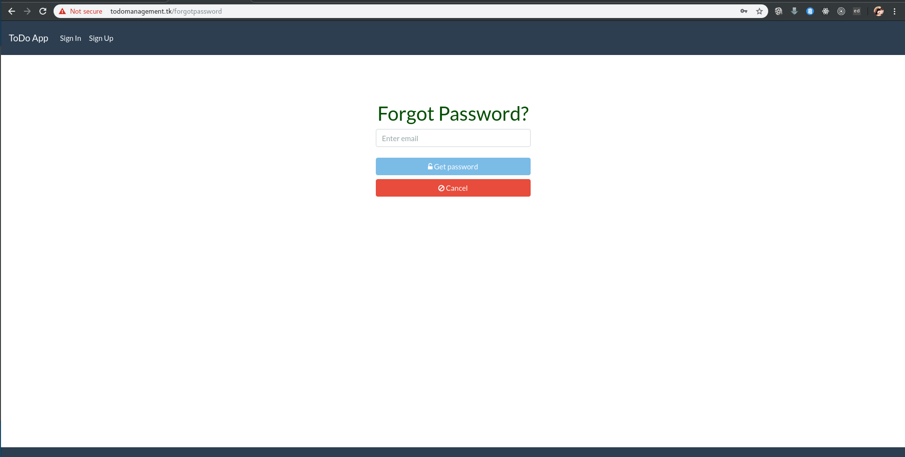

To do list management (single user) –
After successfully login User can create to do list under the tab create by Adding the list where user can edit ,update ,delete and complete the list
Create list
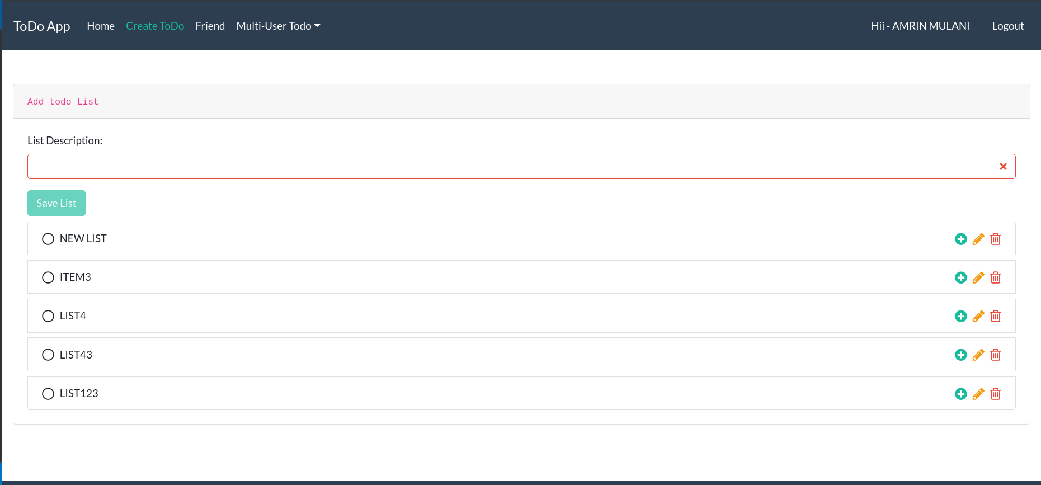
Edit List
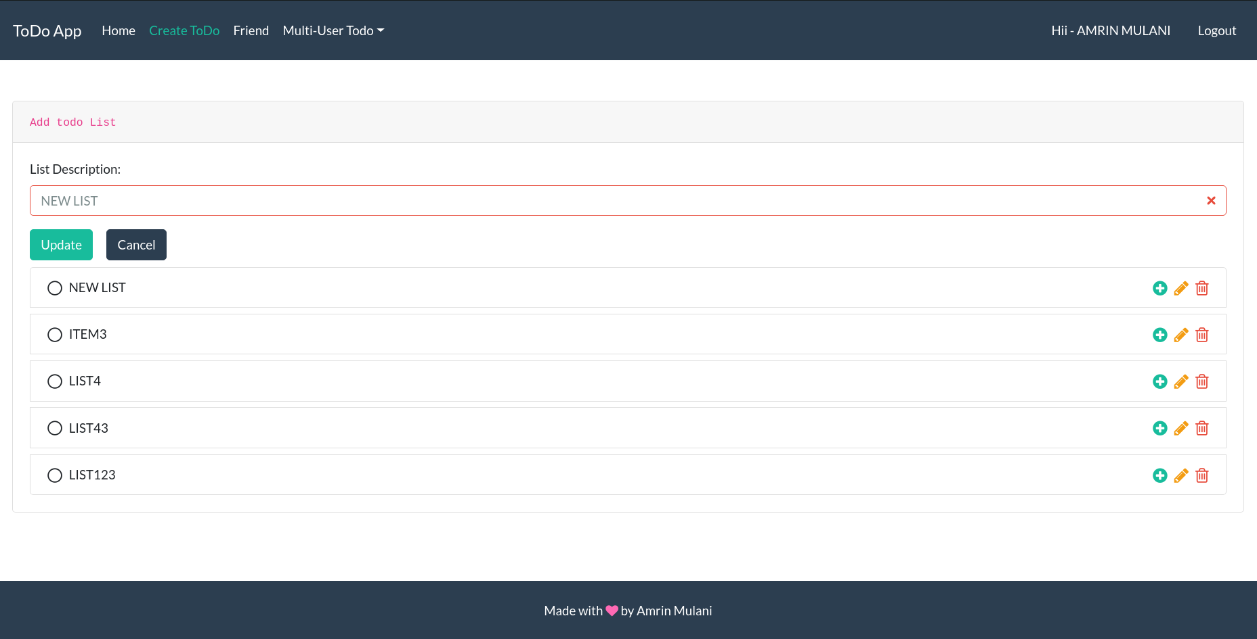

Delete list
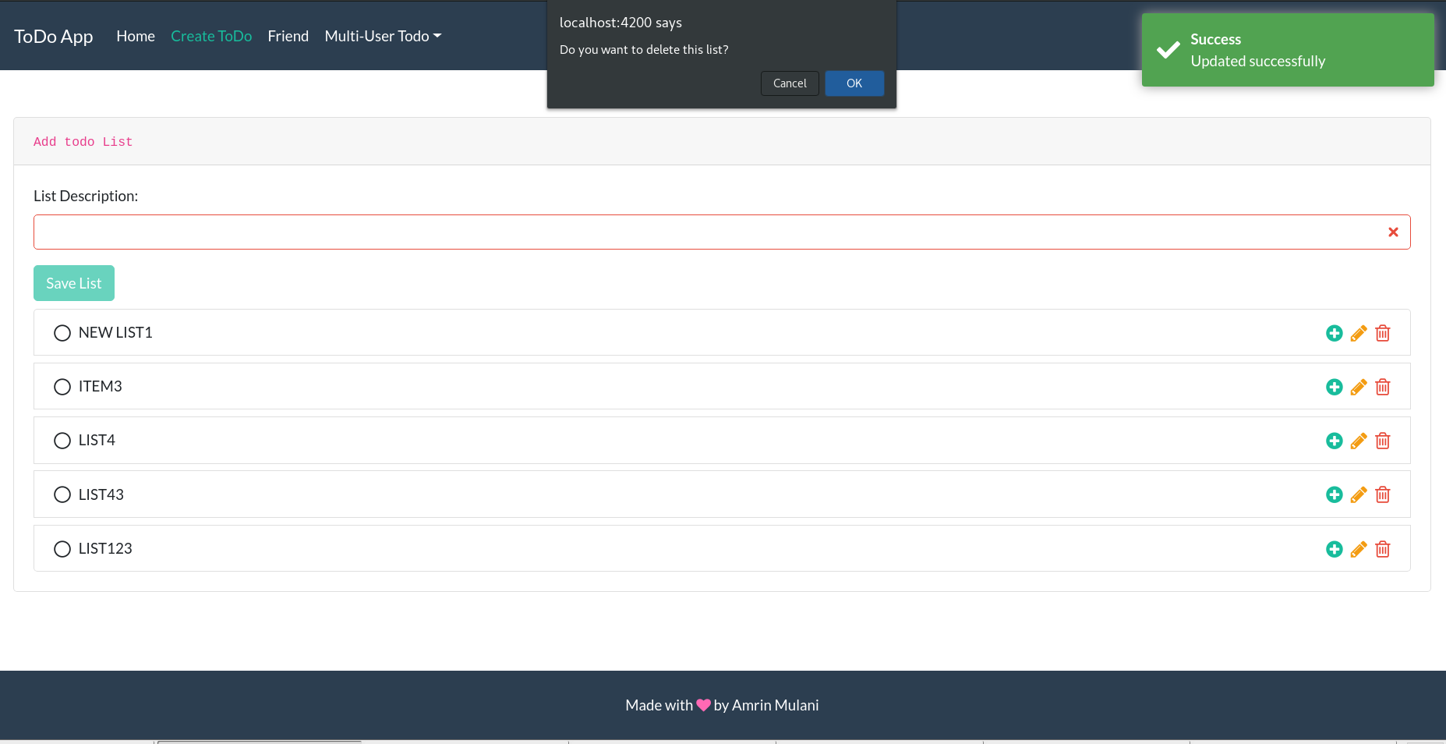
Complete the list
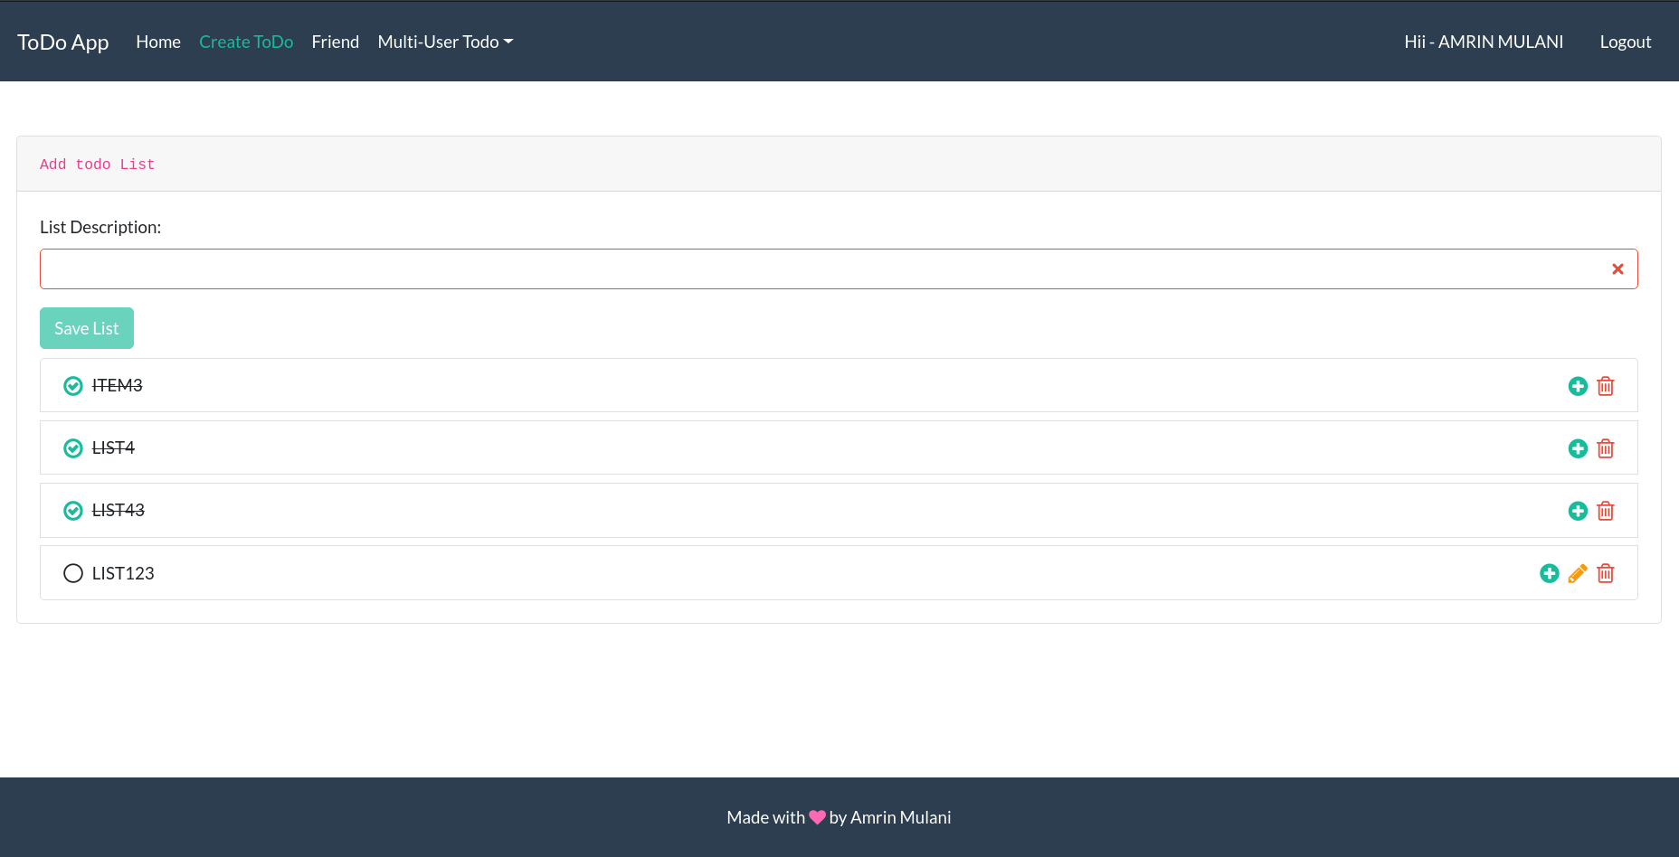

User can add tasks to list user perform action can edit ,update ,delete and complete the task
Create Task
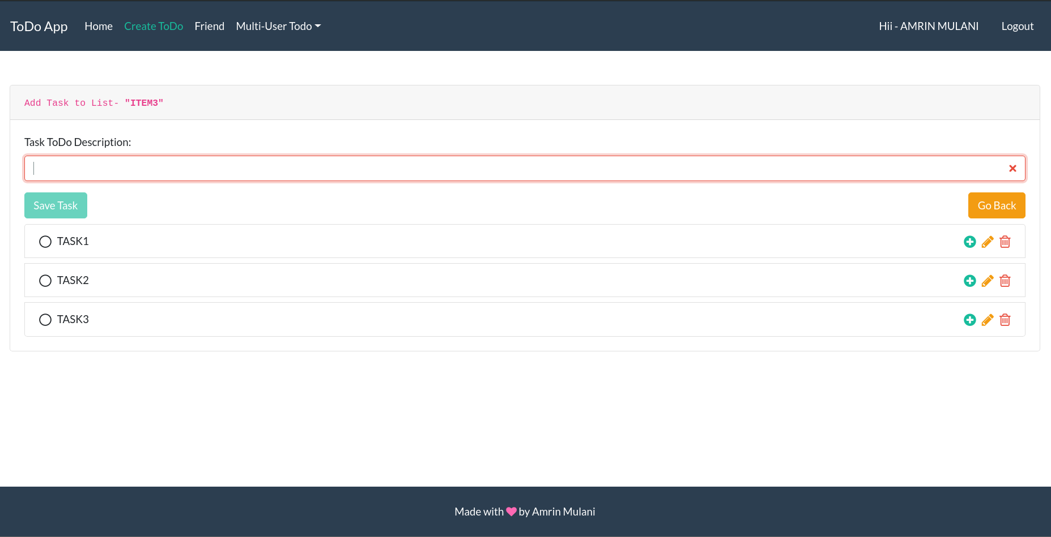
Edit Task
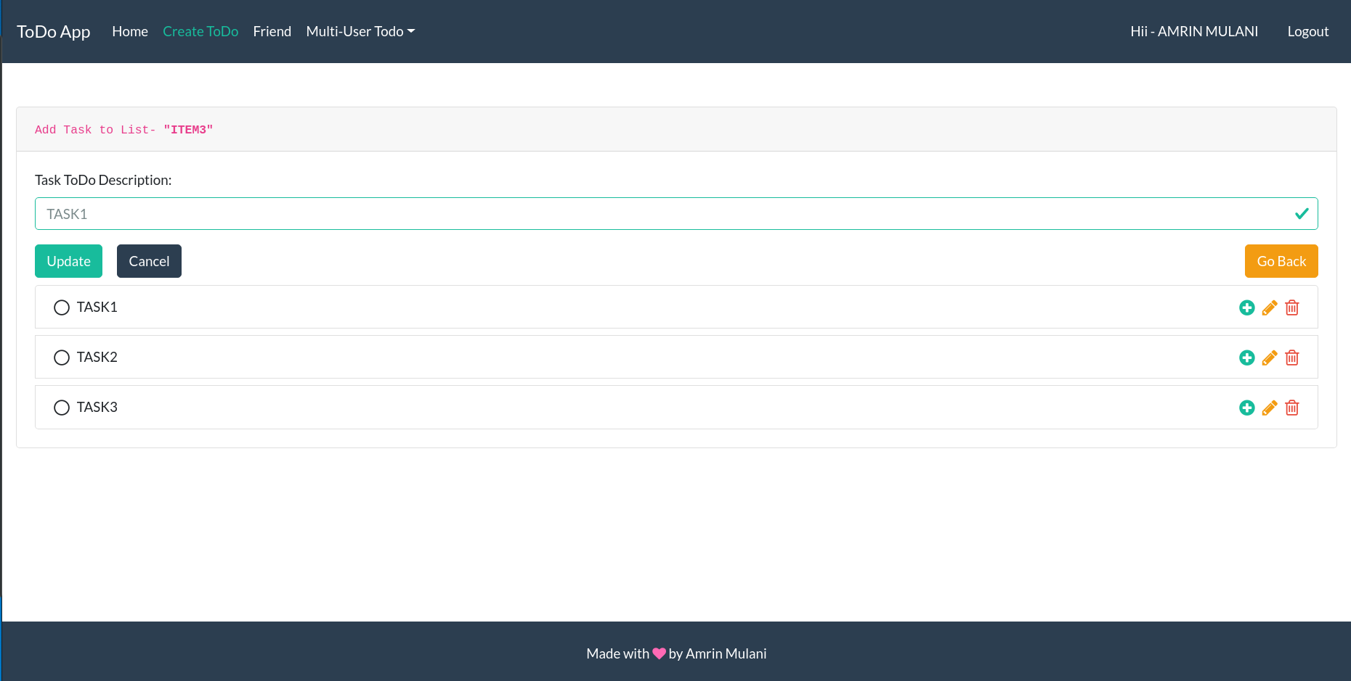
Delete Task
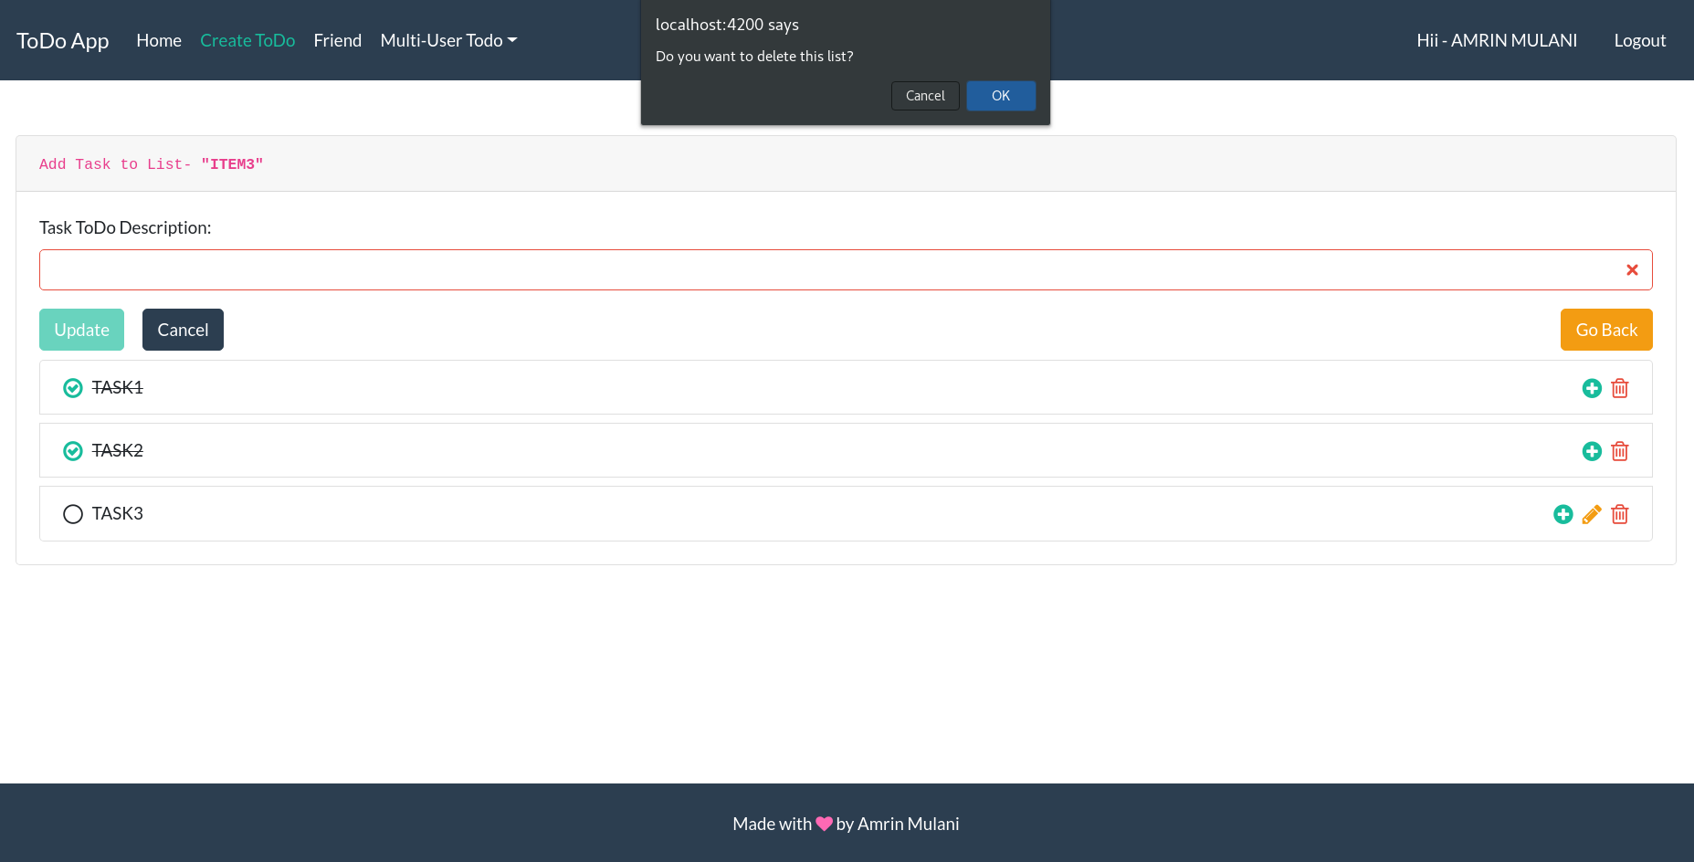
User can add subtasks to task similar way user can perform action edit ,update ,delete and complete the sub task
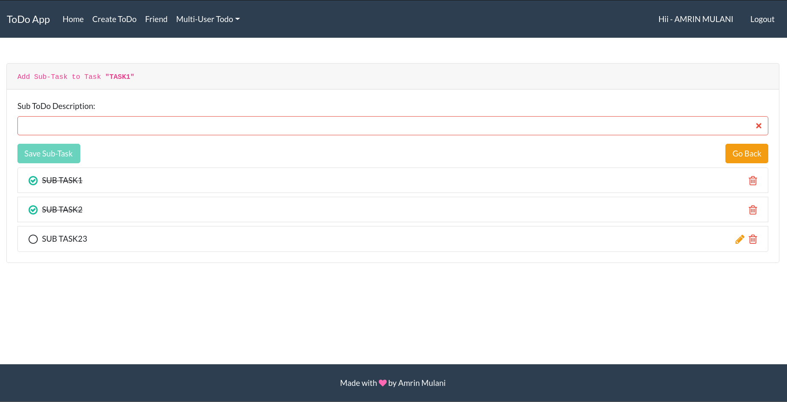

User can view the list tree structure under home tab
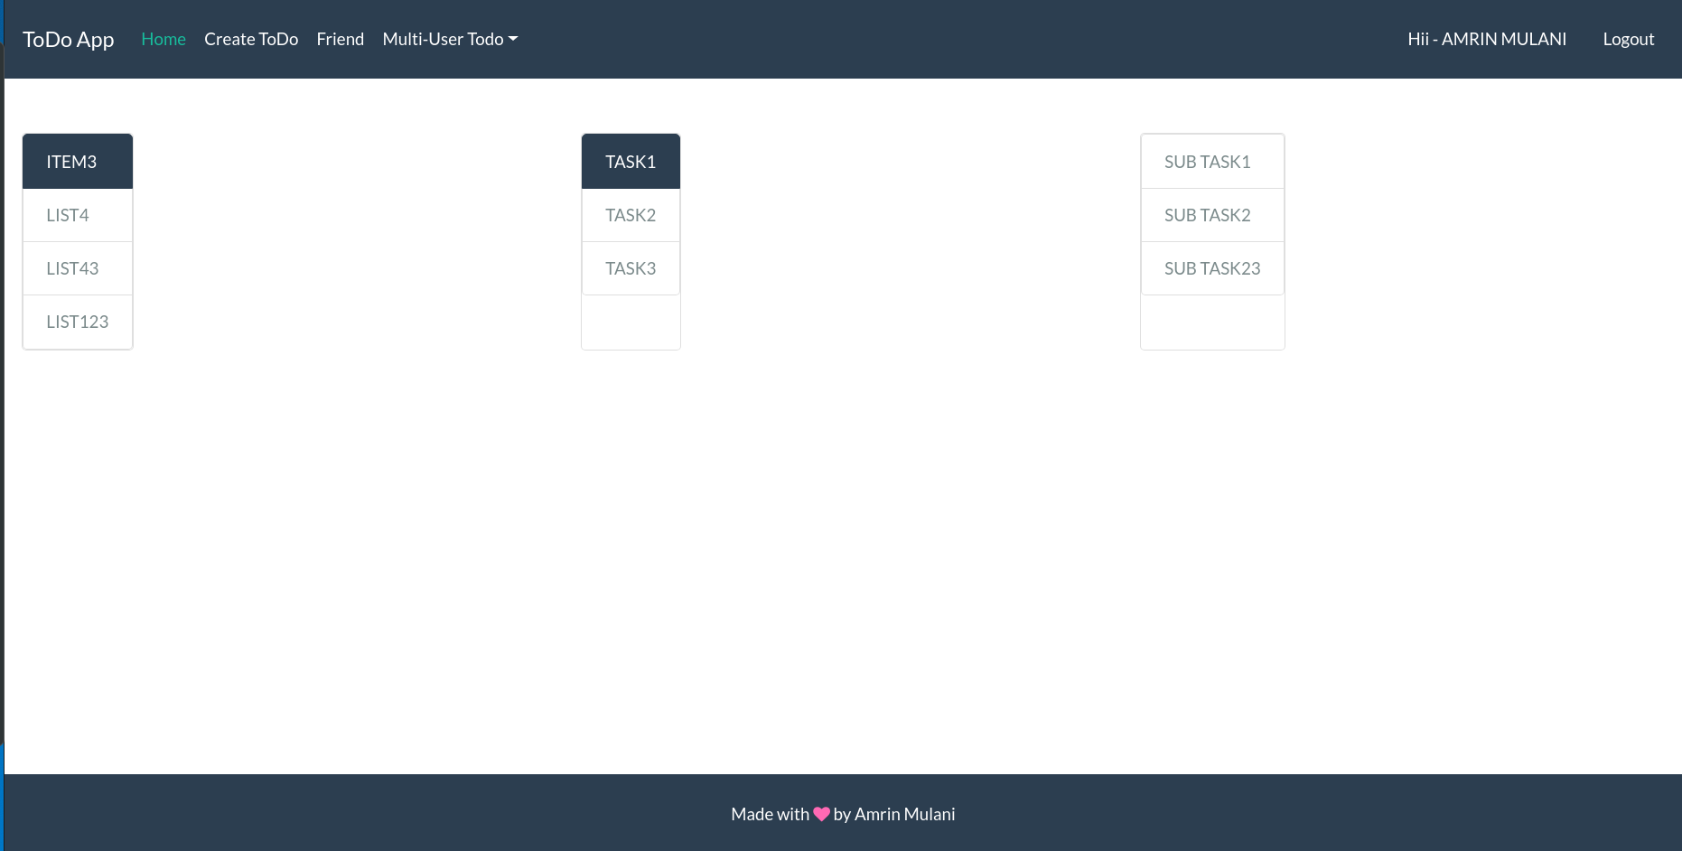

Friend list-
User can view list of the other user
User can send request to other user and other user can receive the notification of friend request
User can view the pending request
User can view receive and accept request from other user and other user receive the notification when user accept the other user request
User can view friends list
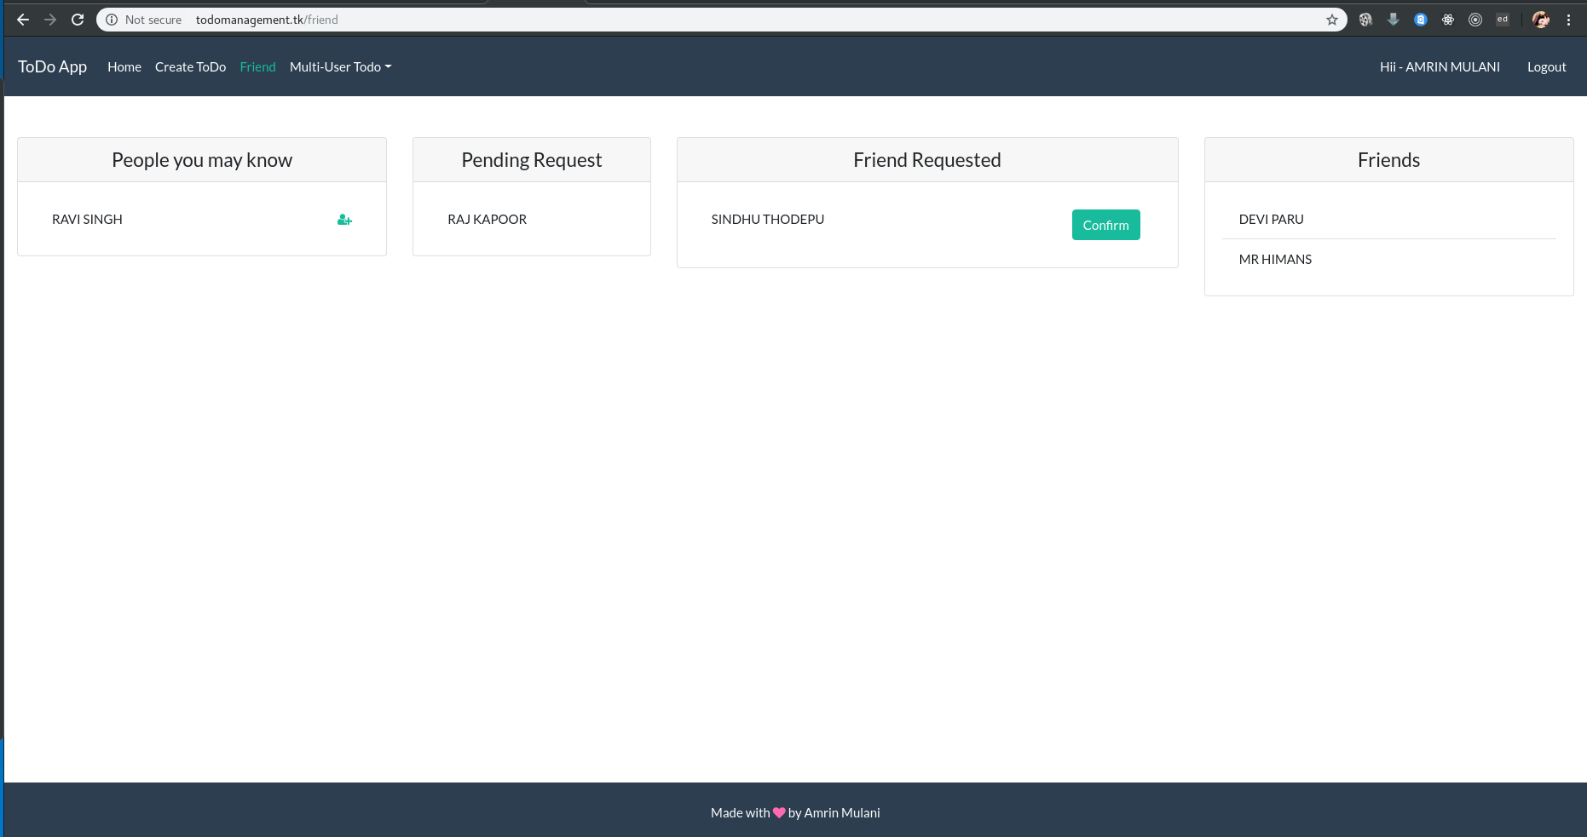

To do List management (multi-user) –
User can create the list for multi user
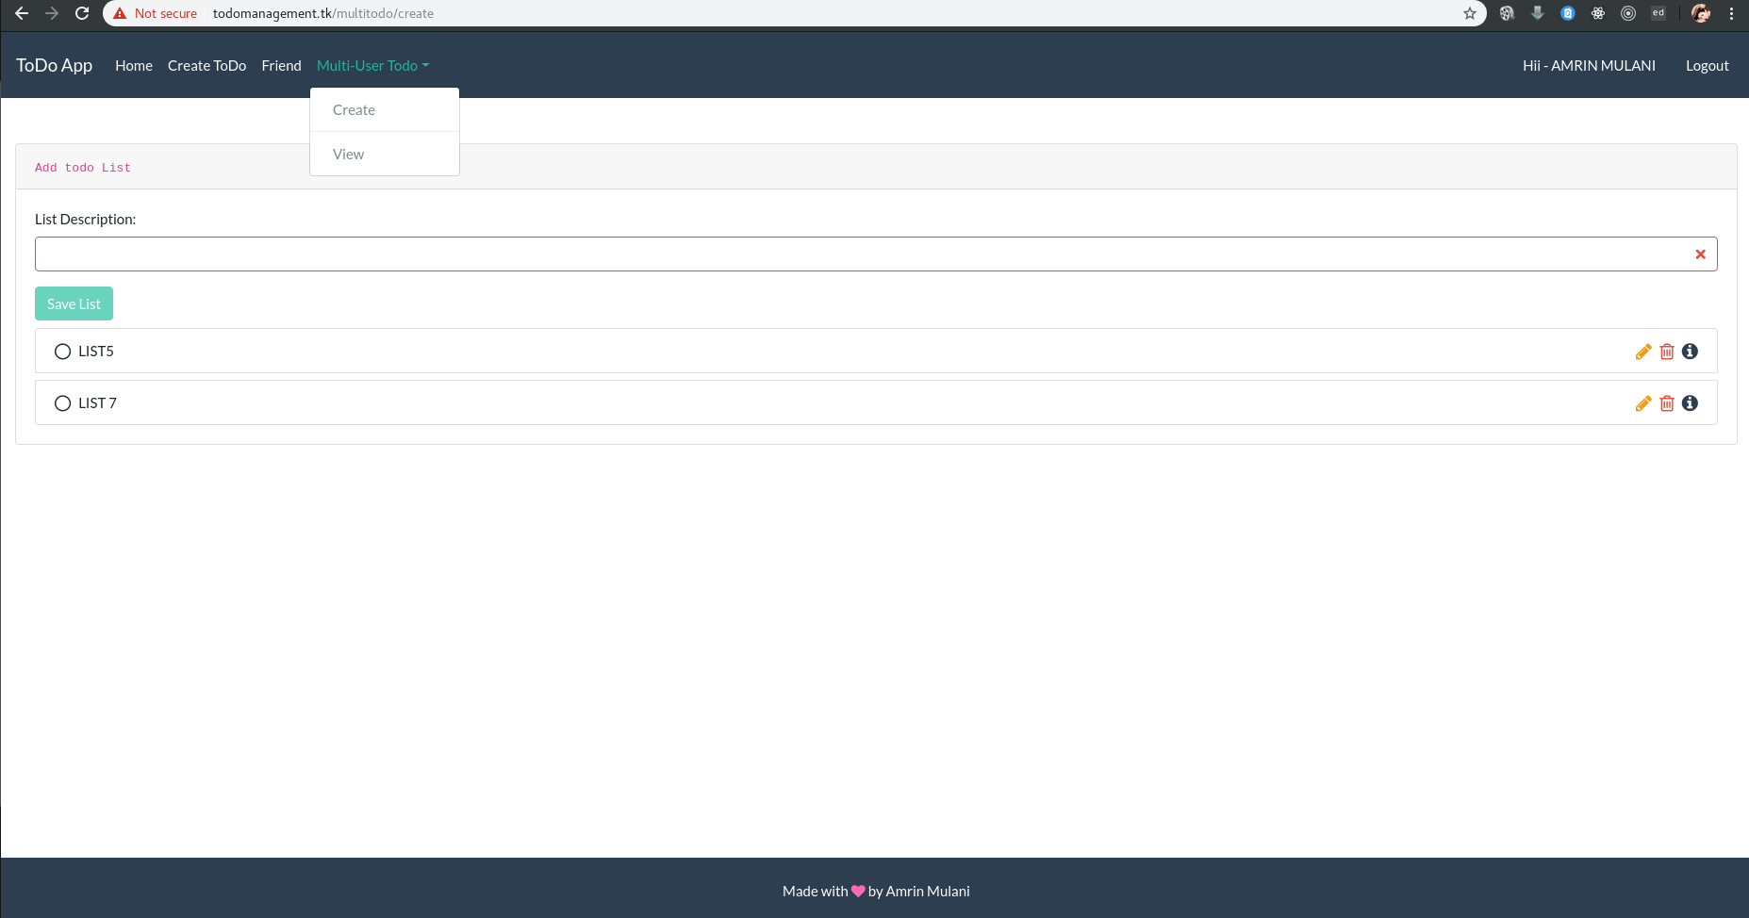
User can view friend multiuser list .User can edit, delete multiuserlist
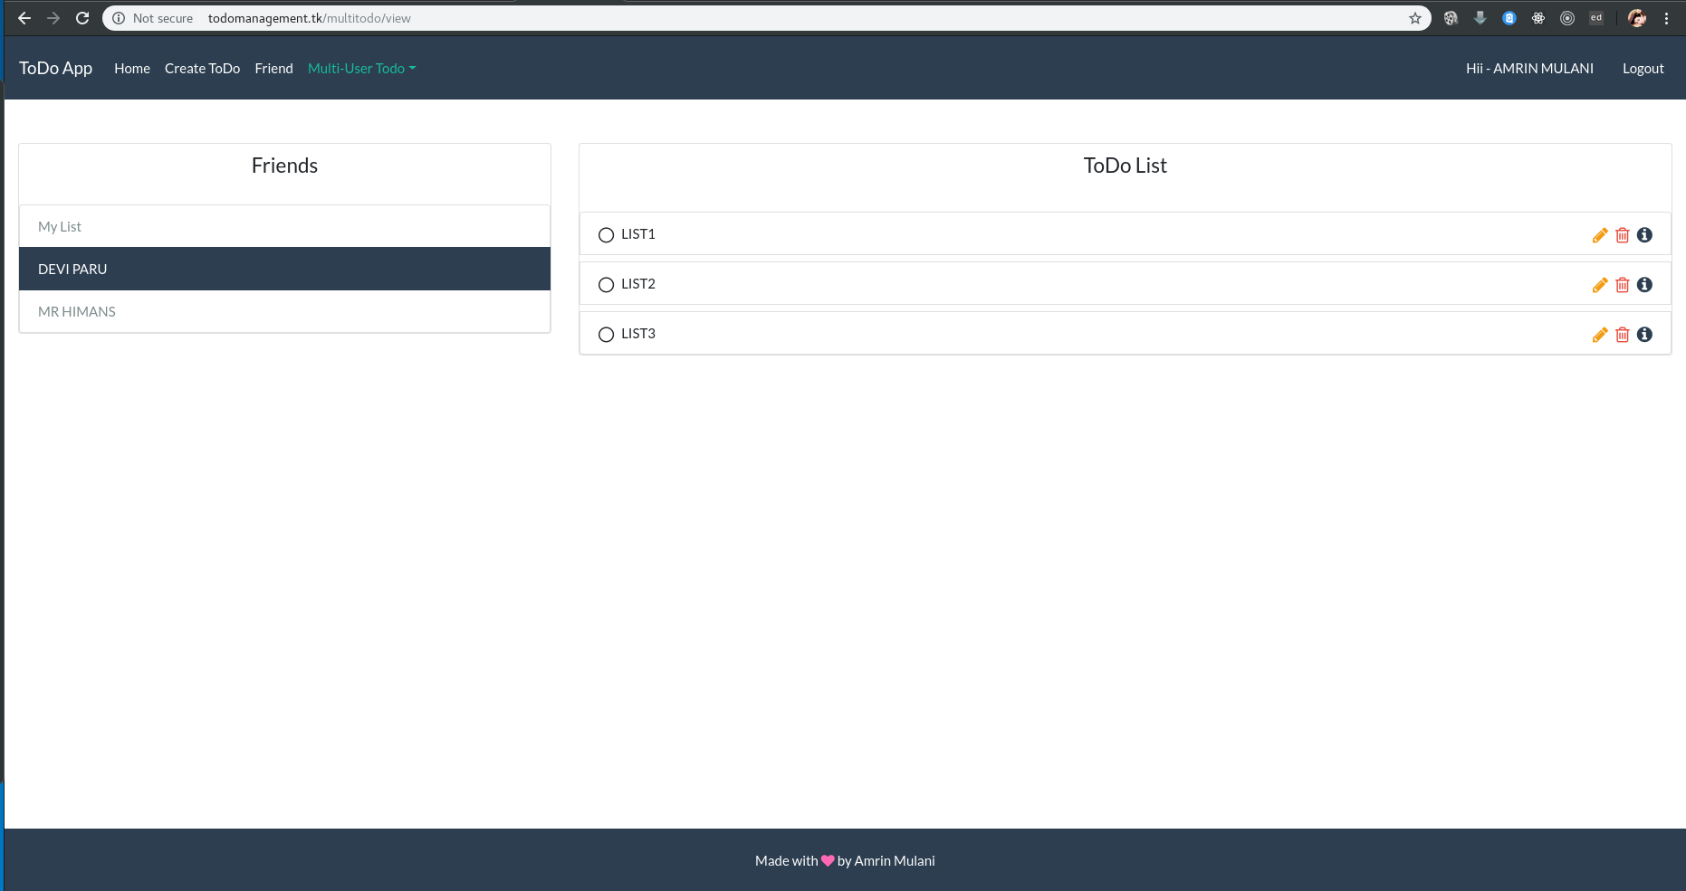
User can edit friend multiuser list
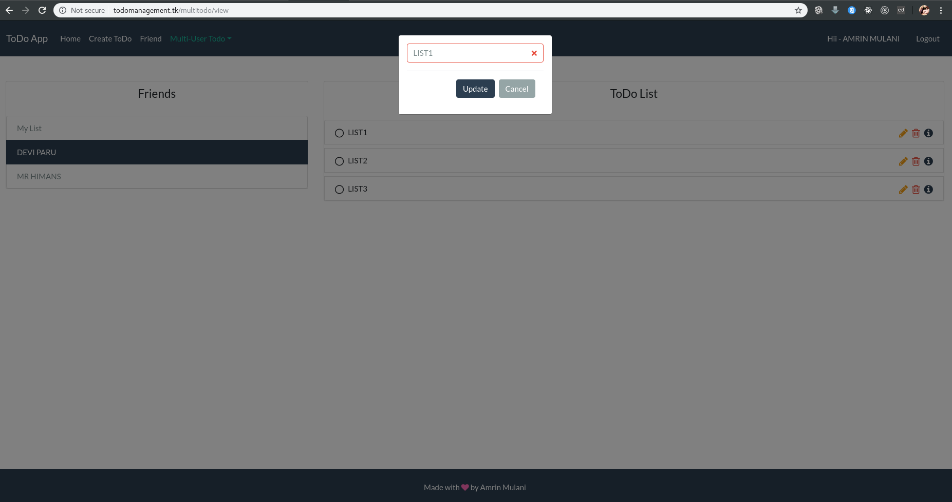
User will receive the notification when multiuser list is edited by the user friend and visa versa
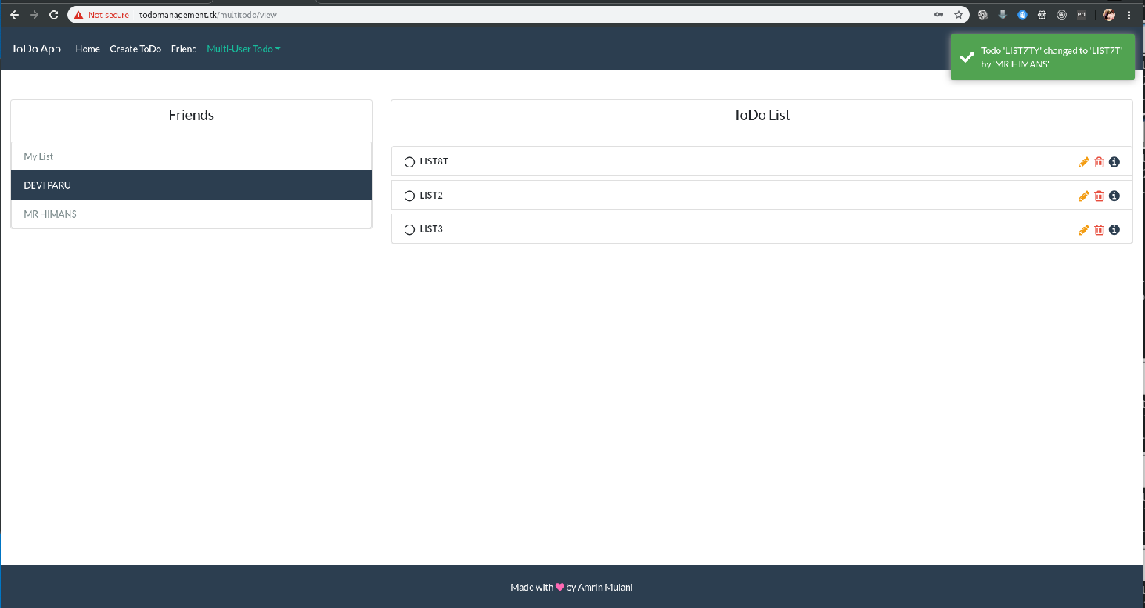

User can view the history of list what past action has been taken on list
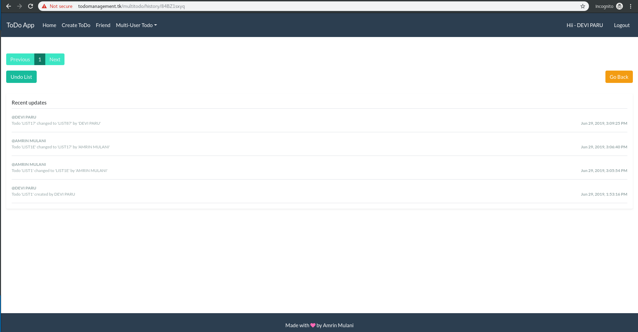

If user/Friend want to undo the edit operation by clicking undo button user can reverse the
Action
